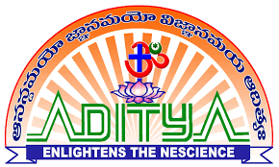
Aditya College of Engineering & Technology
Aditya Nagar, ADB Road, Surampalem – 533437

Financial Assistance to Faculty Members
Academic Year 2022-23
The following is the list of faculty members received financial support for attending Conferences/ Workshops/FDPs / Professional Body Memberships. The amounts are reimbursed as per the policy of the Institution.

S.No | Name of the Faculty | Dept. | Name of the Program | Type  of the Program | Amount
1 | Y.Alekhya | ECE | CONIT-2022, Hubballi,Karnataka, 24-26, June 2022 | Conference | 7,600
2 | I.Ramesh Raja | ECE | RDECS-2022, Aditya Engineering College, Surampalem 22-23, July 2022 | Conference | 15,000
3 | Dr.D.Kishore | ECE | ICCCI-2023, Sri Shakthi Institute of Engineering and Technology, Coimbatore, 23-25 Jan 2023 | Conference | 7,000
4 | Dr.R.Anil Kumar | ECE | ICOEI 2023 ,SCAD college ofEngineering and Technology,Tirunalveli,11-13 April 2023 | Conference | 7,500
5 | V.Preethi | ECE | IICI 2023,Nalanda,BEI Academy of Excellence,Bengaluru,3-5 May 2023 | Conference | 4,000
 | Total |  |  |  | 41,100

